**React Life cycle.**

1. **Mounting**

When the component first comes to life.

React creates the instance of this component for the first time.

Initializes its state.

Runs its hooks.

And, Appends it to the DOM.

1. **Unmounting**

When the component is not needed anymore.

React destroys the instance of this component.

Clears its state.

Cleans up any associated hooks and effects.

And, removes it from the DOM.

NOTE: If the component is unmounted and then mounted again, React treats it as a new instance of the component. The state is re-initialized with its default values, just like when it first mounted.

(unless we explicitly save it somewhere, like in a global state (e.g., Redux) or local storage)

1. **Re-rendering**

Keeps the current state without resetting to useState defaults.

Updates an already existing component with new state or props.

Recalculates the UI based on the updated data.

Runs useEffect or lifecycle methods if needed.

Updates the component in the DOM without unmounting it.

Faster due to just updating not re-mounting.

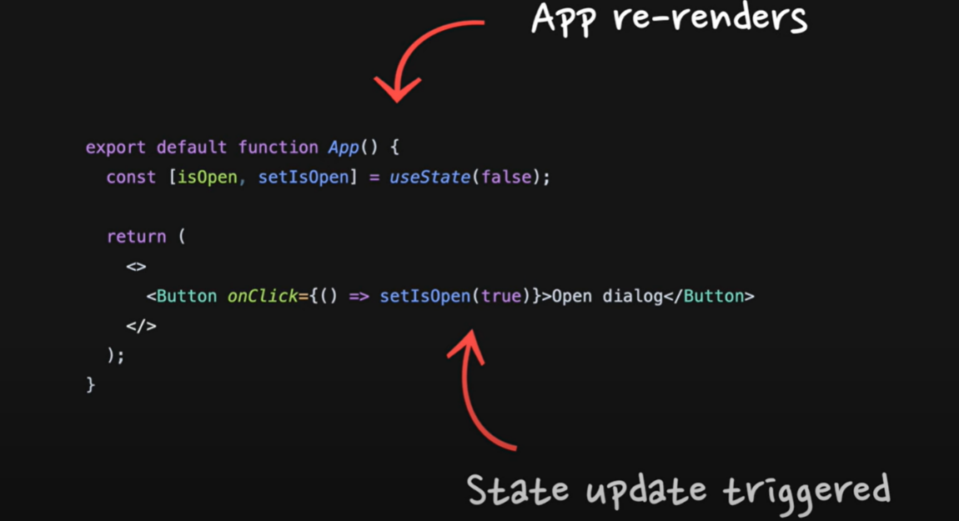

Whenever the **state changes inside the** component, **Everything(children and children’s-children and…….),** under the component **is** **re-rendered**.

**It’s coding time:**

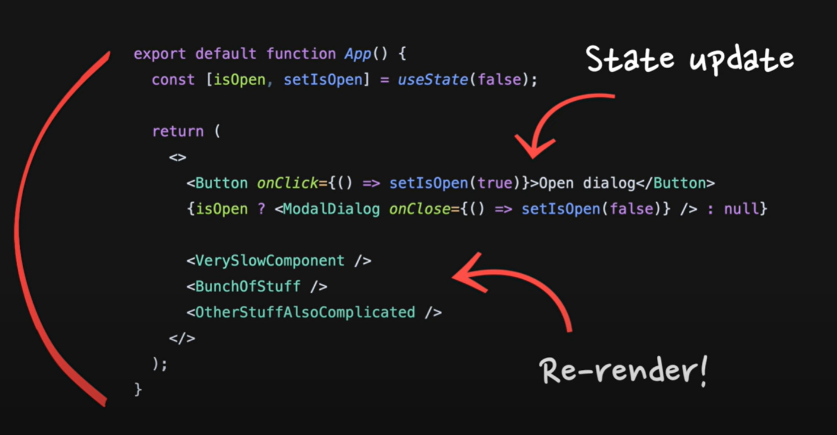

**Problem statement:** Whenever the state changes inside the App, everything is rendered including very slow components so, modal lags to open.

(Solve the above problem with what you have just learned).

**Solution:** Modal is lagging because when isOpen(i.e., state) is updated App is re-rendered so all the components including very slow components are being rendered.

This can be solved as:

1. Create a new component named “ModalWithButton”.
2. Pass all the states and elements using that state to the new component.
3. Use new component in the App.

Since there are no-more state updates in App, so App with not re-render for modal opening(so slow stuffs will also not re-render). It will prevent unnecessary updates in App component. And makes Modal opening Faster(Only “ModalWithButton” will re-render on state update).

**Solution: Moving state down.**

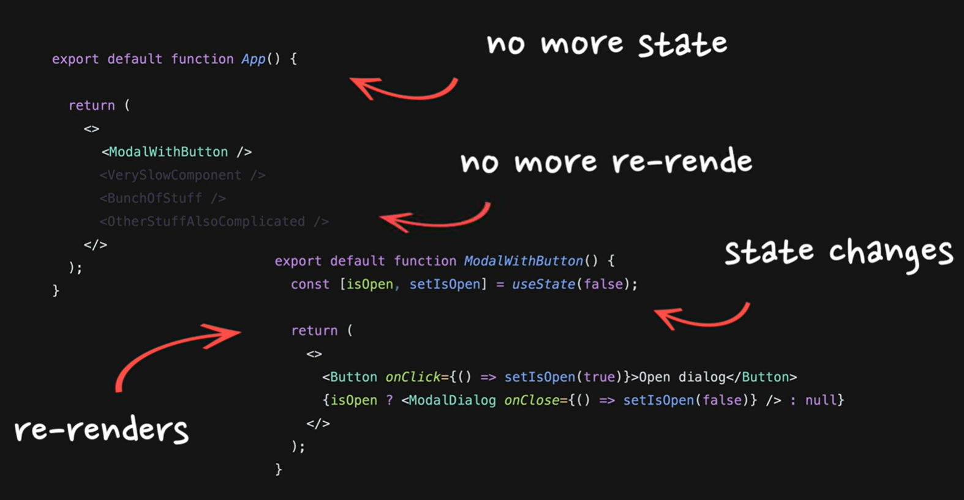

**Try this,**

[**https://codesandbox.io/p/sandbox/example-4-moving-state-down-yc3gyq?file=%2FApp.tsx%3A21%2C32**](https://codesandbox.io/p/sandbox/example-4-moving-state-down-yc3gyq?file=%2FApp.tsx%3A21%2C32)